**DATE : 06/08/2024**

**EXPERIMENT : 01**

**INTODUCTION TO LINUX**

Linux is a free and open-source family of operating systems that is resilient and flexible. In 1991, an individual by the name as Linus Torvalds constructed it. The system’s source code is accessible to everyone for anyone to look at and change, making it cool that anyone can see how the system works. People from all across the world are urged to work together and keep developing Linux due to its openness. Since the beginning, Linux has grown into a dependable and safe OS that is used in an array of gadgets, including PCs, cell phones, and huge supercomputers. It is well-known for being cost-effective, which implies that employing it doesn’t cost a lot, and efficient, which indicates it can complete a lot of jobs quickly.

**HISTORY OF LINUX**

Linus Torvalds designed the free and open-source Linux operating system kernel in 1991. Torvalds set out to develop a free and flexible system for [personal computers,](https://www.geeksforgeeks.org/what-is-pc-personal-computer-intrusion/)drawing ideas from the [UNIX operating system](https://www.geeksforgeeks.org/introduction-to-unix-system/) and the [MINIX operating system.](https://www.geeksforgeeks.org/difference-between-linux-and-minix-3/) Teamwork in development was encouraged with the initial release of the Linux kernel, which attracted developers and enthusiasts globally quickly. Various open-source software packages integrated with the Linux kernel created fully operational operating systems, occasionally referred to as Linux distributions. Over the years, [Linux](https://www.geeksforgeeks.org/introduction-to-linux-operating-system/)has become known as a key component of modern computing, powering everything from servers and personal computers to supercomputers and smartphones. Due to its flexibility, durability, and strong community support, developers, businesses, and educational institutions frequently opt for it.

**LINUX DISTRIBUTION**

[Linux distribution](https://www.geeksforgeeks.org/what-are-linux-distributions/) is an operating system that is made up of a collection of software based on Linux kernel or you can say distribution contains the Linux kernel and supporting libraries and software. And you can get Linux-based operating system by downloading one of the Linux distributions and these distributions are available for different types of devices like embedded devices, personal computers, etc. Around **600 + Linux Distributions** are available and some of the popular Linux distributions are:

* MX Linux
* [Manjaro](https://www.geeksforgeeks.org/installing-and-configuring-jenkins-on-arch-based-linux-distributions-manjaro/)
* Linux Mint
* [elementary](https://www.geeksforgeeks.org/elementary-operations-on-matrices/)
* Ubuntu
* [Debian](https://www.geeksforgeeks.org/introduction-to-debian-linux/)
* [Solus](https://www.geeksforgeeks.org/solus-operating-system/)
* Fedora
* [openSUSE](https://www.geeksforgeeks.org/how-to-find-opensuse-linux-version/)
* [Deepin](https://www.geeksforgeeks.org/how-to-install-deepin-on-virtualbox/)

**HOW TO DOWNLOAD AND INSTALL LINUX**

To install Linux:

1. [Choose an install method](https://learn.microsoft.com/en-us/linux/install#step-1---choose-a-method-to-install-linux): Windows Subsystem for Linux (WSL), Bare metal Linux; or create a Virtual Machine (VM) to run Linux locally or in the cloud.

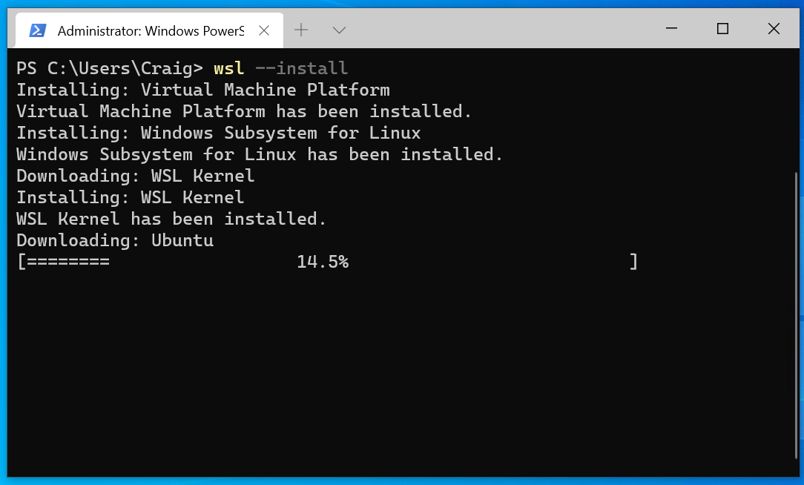

1. [Choose a Linux distribution](https://learn.microsoft.com/en-us/linux/install#step-2---choose-a-linux-distribution): Ubuntu, Debian, Kali Linux, openSUSE, etc.

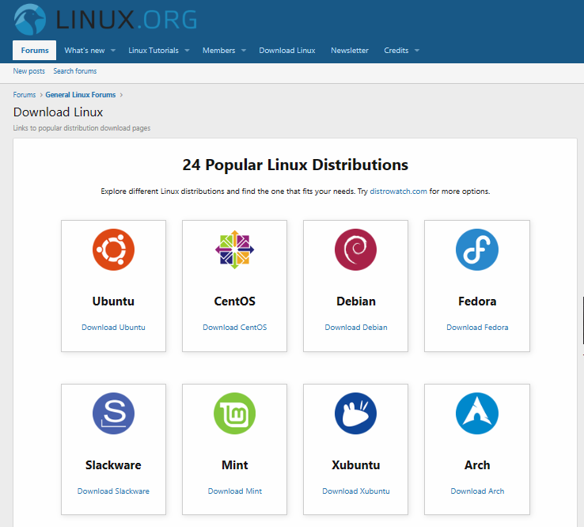

1. [Follow the steps for your preferred install method](https://learn.microsoft.com/en-us/linux/install#step-3---follow-install-method-instructions):
   * [Use the install Linux command with Windows Subsystem for Linux (WSL)](https://learn.microsoft.com/en-us/linux/install#install-linux-with-windows-subsystem-for-linux)

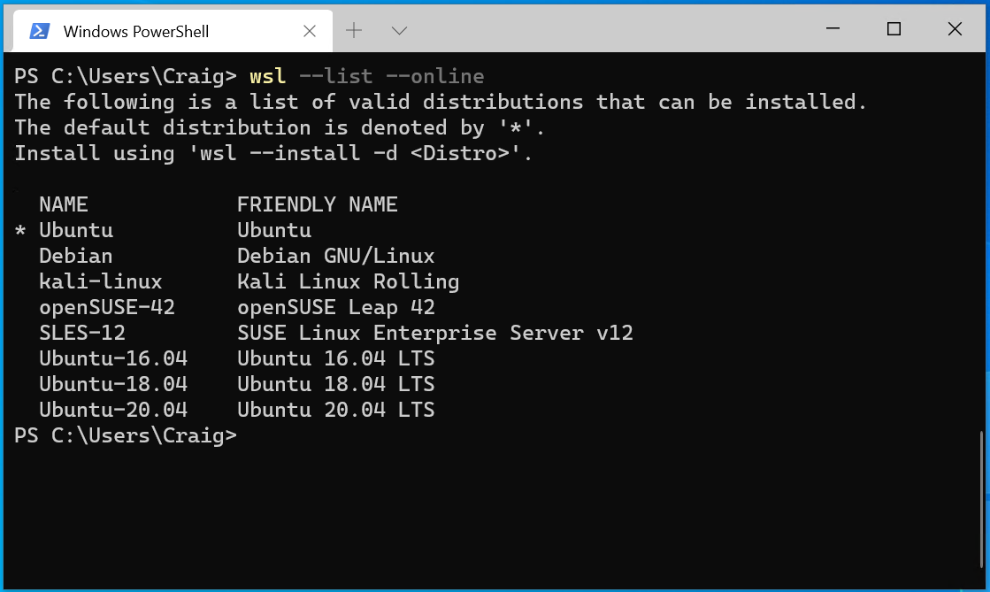

* + [Create a Linux Virtual Machine (VM) in the cloud](https://learn.microsoft.com/en-us/linux/install#create-a-linux-virtual-machine-in-the-cloud)

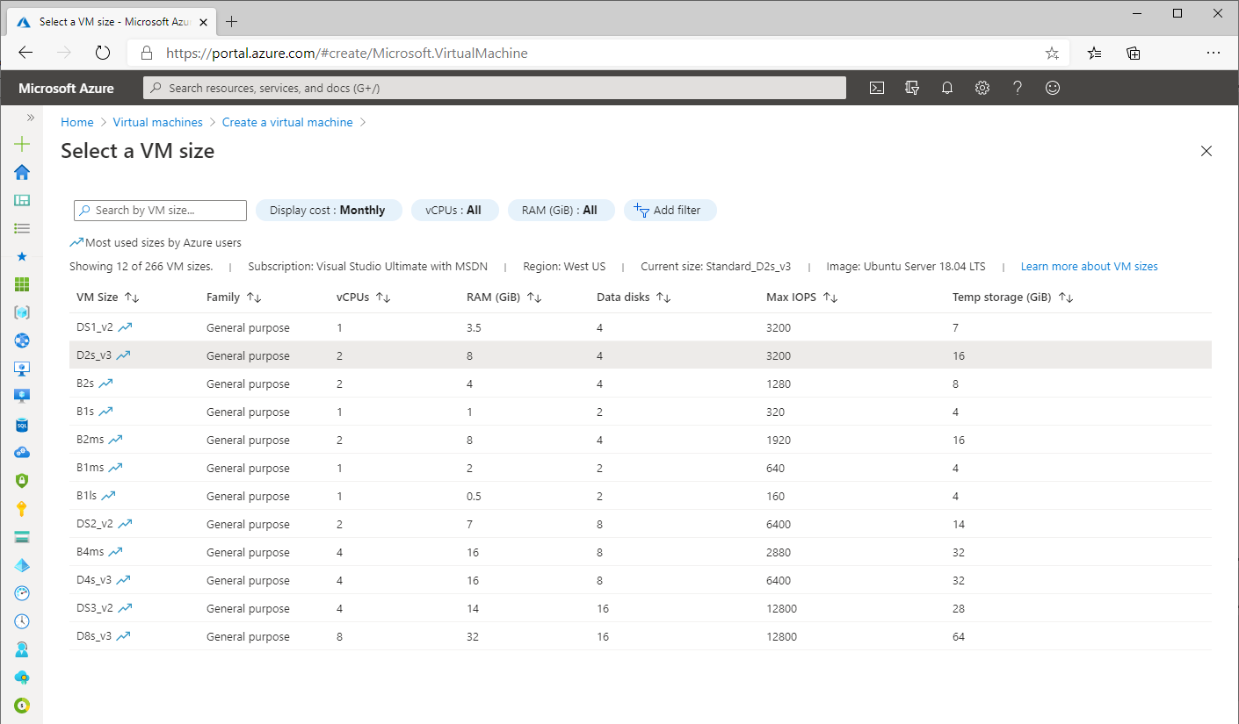

* + [Create a Linux Virtual Machine (VM) on your local machine](https://learn.microsoft.com/en-us/linux/install#create-a-linux-virtual-machine-locally-using-a-hypervisor)

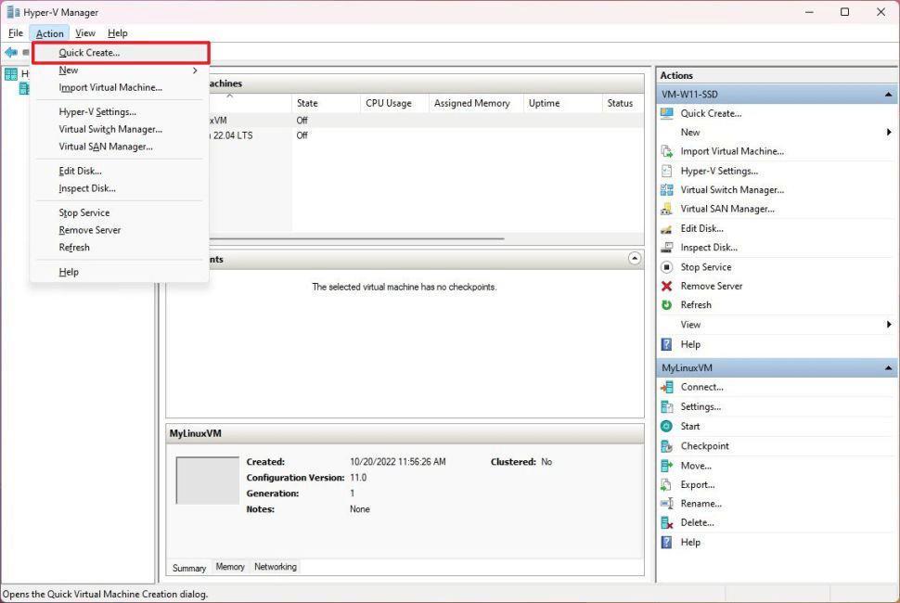

* + [Create a bootable USB to install bare-metal Linux](https://learn.microsoft.com/en-us/linux/install#create-a-bootable-usb-drive-to-install-bare-metal-linux)

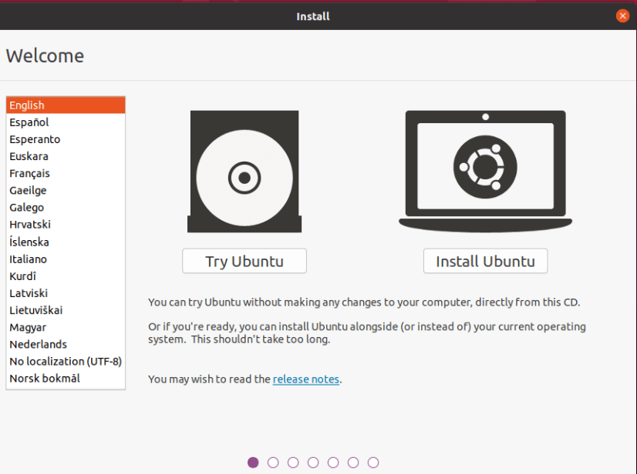

1. [After installing Linux](https://learn.microsoft.com/en-us/linux/install#step-4---after-installing-linux): Get familiar with your distribution's package manager, update and upgrade the packages available, and get familiar with the other [Linux resources at Microsoft](https://learn.microsoft.com/en-us/linux/), such as training courses, Linux-versions of popular tools, news, and Open Source events.

**CLASSIFICATION OF LINUX COMMANDS**

1. File Management Commands
   * chgrp Changes a file's group
   * chmod Changes a file's permissions
   * chown Changes a file's user ownership
   * cp Copies a file
   * dd Converts and copies
2. Text Processing and Scripting Commands
   * awk The awk general-purpose text processing language
   * basename Strips extensions and directories from filenames
   * cat Displays and concatenates files
   * cut Extracts columns of lines
   * cmp Compares binary files
3. Online Documentation Commands
   * info Displays GNU-style documentation
   * man Displays the traditional Unix online manual
4. Process and System Utility Commands
   * at Runs a program at a certain time
   * chfn Changes finger information
   * chsh Changes shells
   * id Shows the current user ID
   * kill Sends a signal to a process
5. System Information Commands
   * arch Displays the system architecture
   * df Displays disk usage statistics
   * dmesg Displays buffered kernel messages
   * finger Displays user information
   * free Displays free memory statistics

### 1. File Management Commands

* **chgrp**
  + **Description:** Changes a file's group ownership.
  + **Example Output:** No output if successful. If there's an error, it might return an error message like chgrp: cannot access 'filename': No such file or directory.
* **chmod**
  + **Description:** Changes file permissions.
  + **Example Output:** No output if successful. Errors might include messages like chmod: cannot access 'filename': No such file or directory.
* **chown**
  + **Description:** Changes file ownership (user and/or group).
  + **Example Output:** No output if successful. Errors might include messages like chown: cannot access 'filename': No such file or directory.
* **cp**
  + **Description:** Copies files and directories.
  + **Example Output:** No output if successful. Errors might include messages like cp: cannot stat 'source': No such file or directory.
* **dd**
  + **Description:** Converts and copies files.
  + **Example Output:** Progress and summary information such as:

yaml

Copy code

1024+0 records in

1024+0 records out

1048576 bytes (1.0 MB, 1.0 MiB) copied, 0.00123456 s, 849 MB/s

### 2. Text Processing and Scripting Commands

* **awk**
  + **Description:** General-purpose text processing.
  + **Example Output:** Varies based on the awk program provided. For instance, awk '{print $1}' file.txt will output the first column of each line in file.txt.
* **basename**
  + **Description:** Strips directory and suffix from filenames.
  + **Example Output:**

Copy code

filename

* **cat**
  + **Description:** Concatenates and displays file contents.
  + **Example Output:** Displays the contents of the file:

csharp

Copy code

This is the content of the file.

* **cut**
  + **Description:** Extracts sections from lines of files.
  + **Example Output:** Based on the specified delimiter and field:

Copy code

field1

field2

* **cmp**
  + **Description:** Compares two files byte by byte.
  + **Example Output:** If files differ, it outputs the first differing byte position:

arduino

Copy code

files differ: byte 2, line 1

If files are the same, there's no output (it returns to the prompt).

### 3. Online Documentation Commands

* **info**
  + **Description:** Displays GNU-style documentation.
  + **Example Output:** Opens a pager interface with documentation for the specified command or topic.
* **man**
  + **Description:** Displays the Unix manual.
  + **Example Output:** Opens a pager with the manual page for the specified command, e.g. man ls displays the manual for the ls command.

### 4. Process and System Utility Commands

* **at**
  + **Description:** Schedules commands to run at a specified time.
  + **Example Output:** Confirmation message, e.g., job 1 at 2024-08-07 09:00.
* **chfn**
  + **Description:** Changes user finger information.
  + **Example Output:** No output if successful. Errors might include messages like chfn: cannot change finger information for 'username': No such user.
* **chsh**
  + **Description:** Changes the default shell for a user.
  + **Example Output:** No output if successful. Errors might include messages like chsh: /bin/bash is not a valid shell.
* **id**
  + **Description:** Displays user and group information.
  + **Example Output:**

scss

Copy code

uid=1000(username) gid=1000(username) groups=1000(username),27_sudo

* **kill**
  + **Description:** Sends a signal to a process.
  + **Example Output:** No output if successful. Errors might include messages like kill: (pid) - No such process.

### 5. System Information Commands

* **arch**
  + **Description:** Displays the system architecture.
  + **Example Output:**

Copy code

x86_64

* **df**
  + **Description:** Displays disk usage.
  + **Example Output:**

bash

Copy code

Filesystem 1K-blocks Used Available Use% Mounted on

/dev/sda1 10240000 5123456 4096000 50% /

* **dmesg**
  + **Description:** Displays kernel ring buffer messages.
  + **Example Output:**

less

Copy code

[ 0.000000] Booting Linux on physical CPU 0x0

[ 0.000000] Linux version 5.4.0-42-generic (buildd@lcy01-amd64-008) (gcc version 9.3.0 (Ubuntu 9.3.0-17ubuntu1~20.04)) #46-Ubuntu SMP Fri Jul 10 20:48:13 UTC 2020 (Ubuntu 5.4.0-42.46-generic 5.4.40)

* **finger**
  + **Description:** Displays information about users.
  + **Example Output:**

javascript

Copy code

Login: username Name: User Name

Directory: /home/username Shell: /bin/bash

* **free**
  + **Description:** Displays memory usage statistics.
  + **Example Output:**

vbnet

Copy code

total used free shared buff/cache available

Mem: 16383548 1021040 7437764 156580 8484744 14822948

Swap: 2097148 0 2097148